FUTURE INTERNS INTERNSHIP

TASK 1

BY MANVI
EMAIL : manvi212223@gmail.com
Date : 6-7-2026



Business Sales Performance Report

Dataset used:
Superstore dataset from Kaggle
Objective
The objective of this project is to analyse the Superstore Sales Dataset to identify sales trends, regional performance, product performance, and profitability. The project uses Python for data analysis and Power BI for dashboard visualization to support business decision-making.
Dataset Information
Dataset: Superstore.csv (from Kaggle)
No of rows: 9994
No of columns: 21
Tools Used:
Python (VS code)
Pandas
Matplotlib
Jupyter Notebook
Power BI
KPIs:
Total sales: 2297200.8603
Total profit: 286397.0217
Total orders: 5009
Average sales: 229.85800083049827
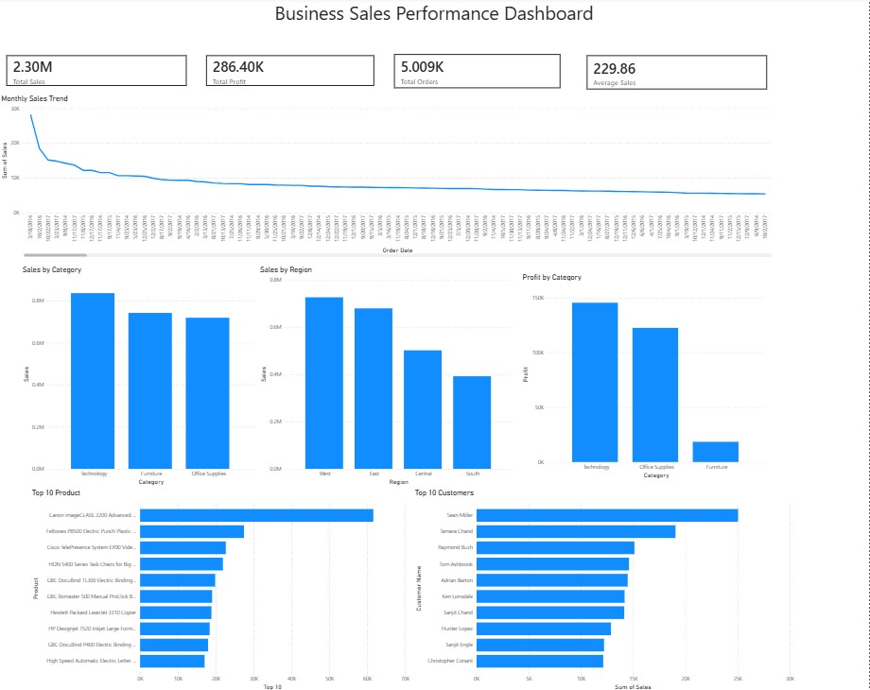
Business Insights:
- The business generated $2.30 million in total sales.
- Total profit was approximately $286.40K.
- The dataset contains 5009 unique customer orders.
- Sales differ across categories and regions, indicating varying market performance.
- Top-selling products contribute significantly to total revenue.
- Monthly sales trends reveal fluctuations that may indicate seasonal demand.

1. Technology is the highest-performing category.
Technology generated the highest sales as well as the highest overall profit, making it the most valuable product category.

2. Furniture generated high sales but comparatively lower profit.
Although Furniture contributed significantly to revenue, its profit was much lower than Technology and Office Supplies, suggesting lower profit margins.

3. West Region recorded the highest sales.
Among all regions, the West region contributed the highest sales, followed closely by the East region.

4. South Region generated the lowest sales.
The South region showed the lowest sales performance and may require additional marketing efforts.

5. A few products contribute a large portion of revenue.
The Top 10 products generated significantly higher sales than the remaining products, indicating that a small group of products drives a large share of revenue.

6. Customer spending varies considerably.
Some customers, such as Sean Miller and Tamara Chand, contribute much higher sales than the average customer.

7. Monthly sales fluctuate over time.
The sales trend shows fluctuations across different months, indicating seasonal variations in customer demand.
Recommendations
Based on the analysis, the following recommendations are suggested:
- Increase inventory for Technology products due to their high sales and profitability.
- Develop marketing campaigns for the South region to improve sales.
- Review pricing and discount strategies for Furniture to improve profit margins.
- Strengthen customer loyalty programs for top customers to increase repeat purchases.
- Promote high-performing products while identifying opportunities to improve low-performing products.
- Monitor monthly sales trends to improve inventory planning and demand forecasting.

Conclusion
This project successfully analysed the Superstore Sales Dataset using Python and Power BI.
Python was used for data cleaning, KPI calculation, and exploratory analysis, while Power BI was used to build an interactive dashboard for visualization.
The analysis identified important business trends, regional performance, profitable categories, and customer purchasing behaviour. The dashboard provides valuable insights that can help businesses make informed decisions regarding sales strategy, marketing, and inventory management.
Overall, this project demonstrates the practical use of data analytics and business intelligence tools to convert raw data into meaningful business insights.

